

**The Red Suite**

***No 4.***

***Newsletter***

***October 2016***

***The Rainham Healthy Living Centre***

Smoking

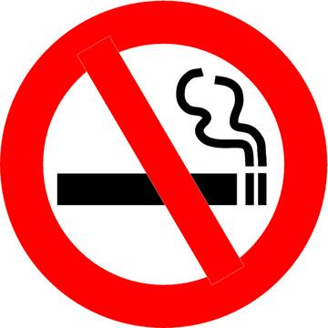

From Monday 17th October all of Medway NHS sites will become smoke-free. All patients, visitors and staff will be banned from smoking in buildings, hospital grounds and car parks. If you are currently a smoker and wish to quit for good, contact Medway Stop Smoking Service on 01634 334800 who will be happy to help you!

Have you had your flu jab?

If you’re 65 and over or suffer from a chronic condition such as asthma, diabetes, COPD or another similar condition, then you are eligible for a free flu jab. If you haven’t had one yet this year then feel free to book one with the receptionist.

If you have received a letter from us inviting you for one but you do not wish to have one, then please inform the receptionists who will remove you from the invitation list so we will not invite you again this year.

DNA Monitoring

Each month we monitor the number of appointments that are wasted by patients that DNA (did not attend).

See below our latest record of DNAs:

July 2016: 7hours 10minutes which equals 43 appointments!

August 2016: 5hours and 40minutes which equals 34 appointments!

September 2016: 8hours 50minutes which equals 53 appointments!

It’s very important that if you are unable to keep an appointment you telephone us to let us know. This way we can offer the appointments to other patients.



Letters are now sent out to patients who miss an appointment and under the discretion of the Doctors if you miss 3 or more appointments we have the right to remove you from our practice list.



**D**

**N**

**A**

**OUT**